[CREATE AND CONFIGURE IBM CLOUD SERVICES](https://careereducation.smartinternz.com/Student/guided_project_workspace/5751)

**CREATE NODE-RED SERVICE**

|  |  |
| --- | --- |
| Date | 15 November 2022 |
| Team ID | PNT2022TMID52217 |
| Project Name | Smart Solutions For Railways |

IBM Cloud-NODE RED account created successfully.

# Team Leader - IBM cloud NODE-RED account created : (SNEHA A)

1. **Create a Node RED account on the IBM Cloud:**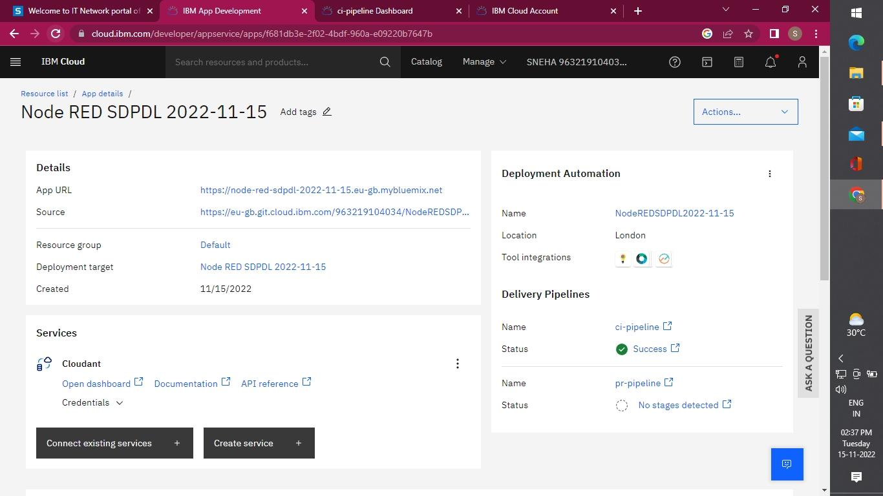
2. **Node-RED on IBM Cloud:**

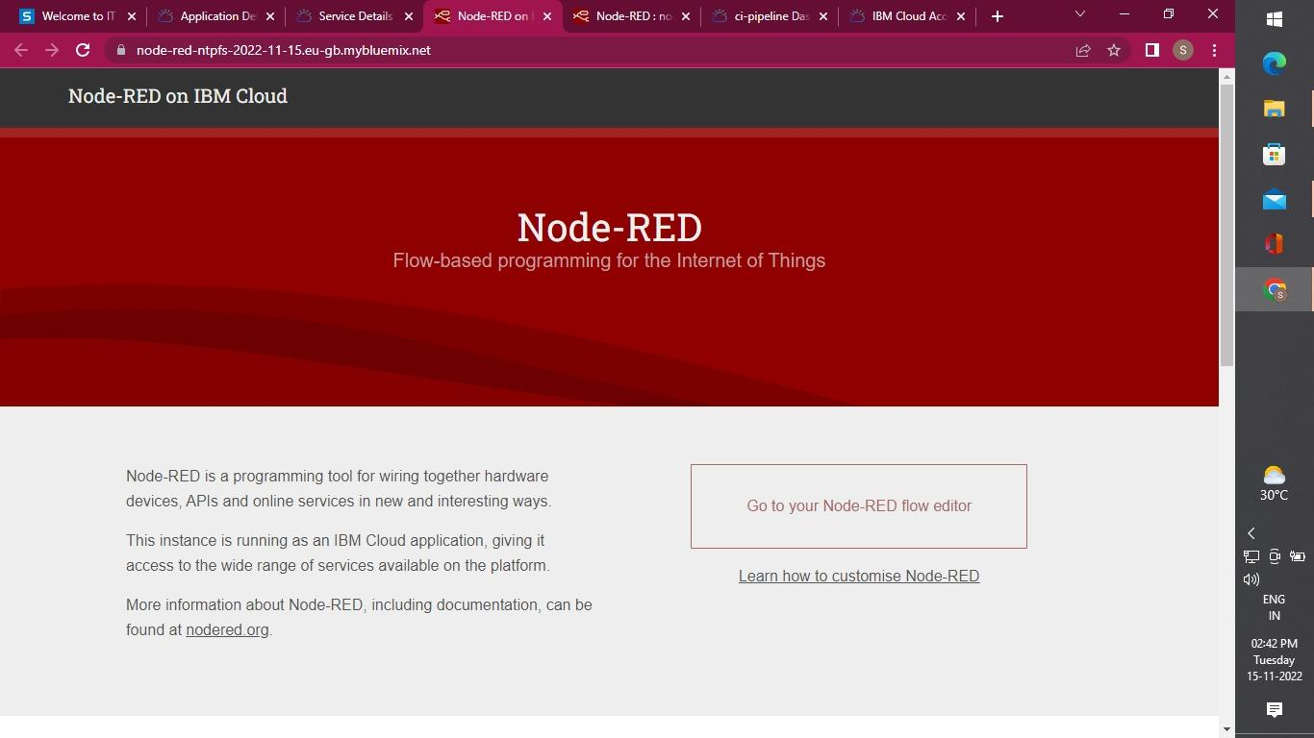

1. **Start the NODE RED application to build the projects :**

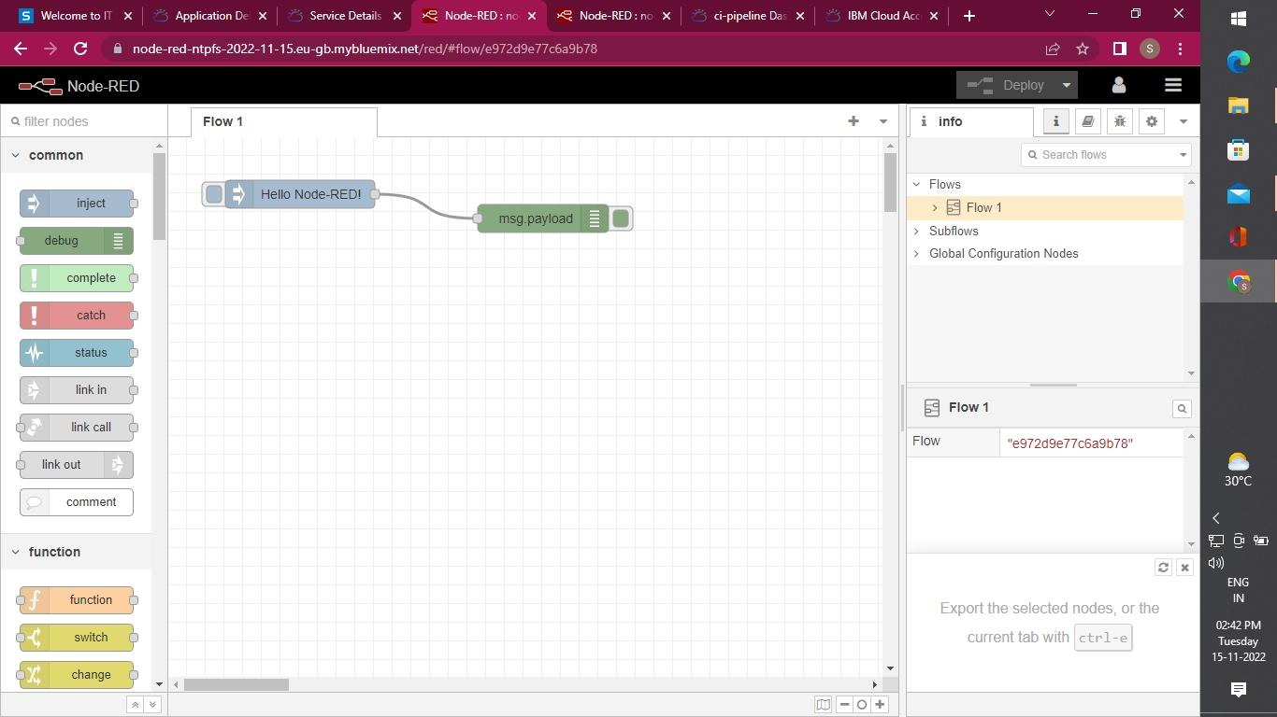

# Team Member 1 - IBM cloud NODE-RED account creation : (Lebila M )

1. **Create a Node RED account on the IBM Cloud :**

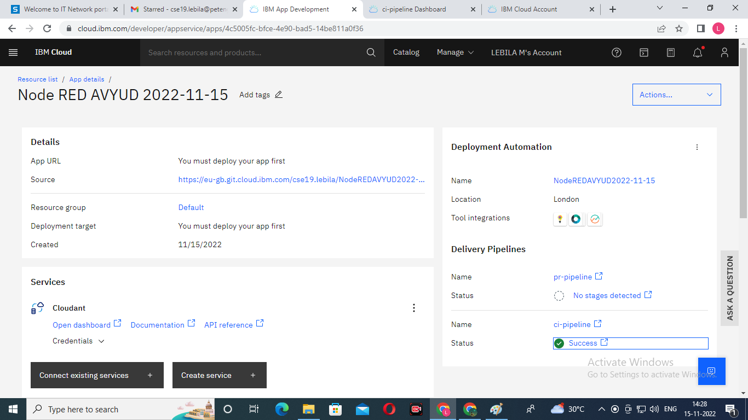

1. **Node-RED on IBM Cloud:**

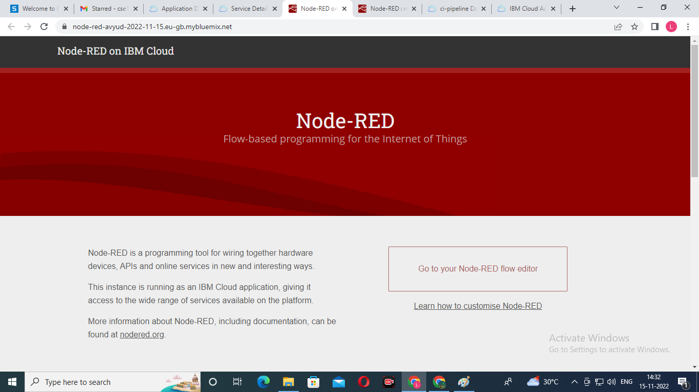

1. **Start the NODE RED application to build the projects :**

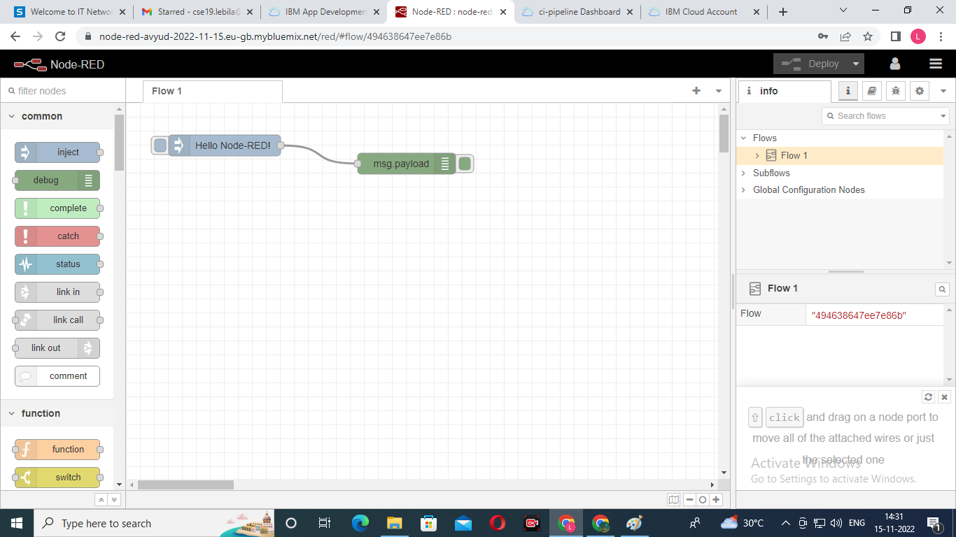

# Team Member 2- IBM cloud NODE_RED account creation : (Melda M)

1. **Create a Node RED account on the IBM Cloud:**

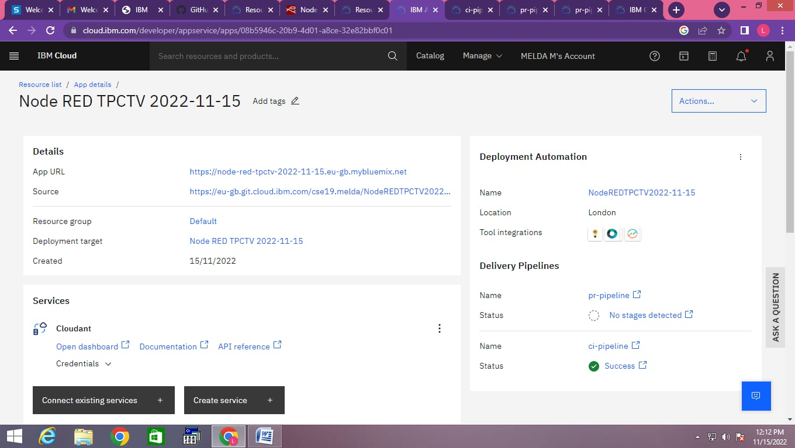

1. **Node-RED on IBM Cloud:**

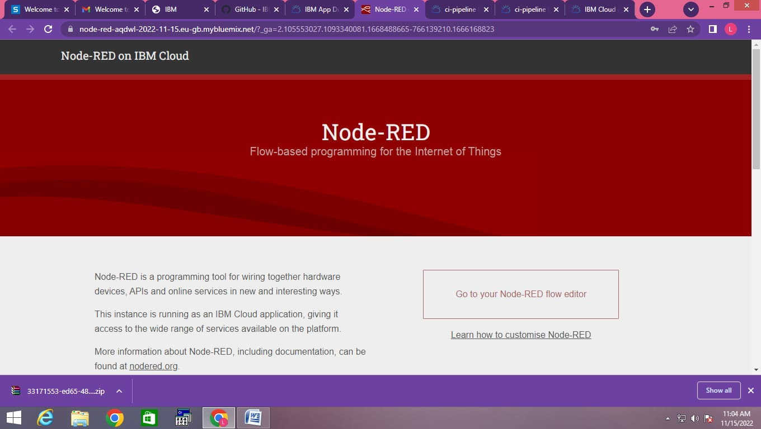

1. **Start the NODE RED application to build the projects :**

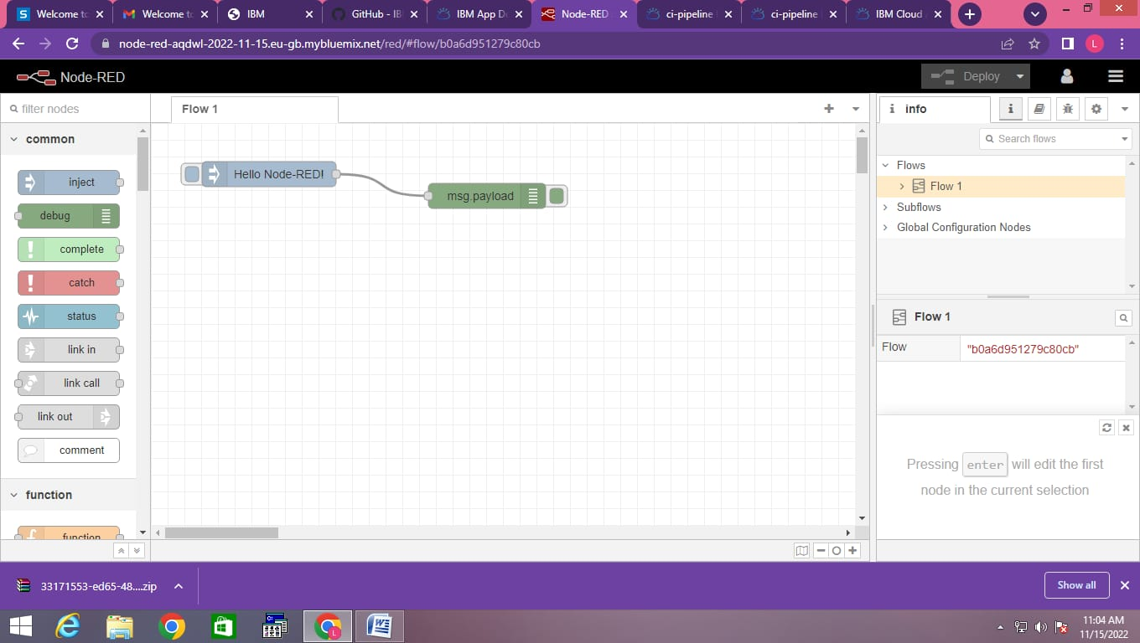

# Team Member 3 - IBM Cloud NODE-RED account creation : (Mohammed Lamees Umama S S)

1. **Create a Node RED account on the IBM Cloud:**

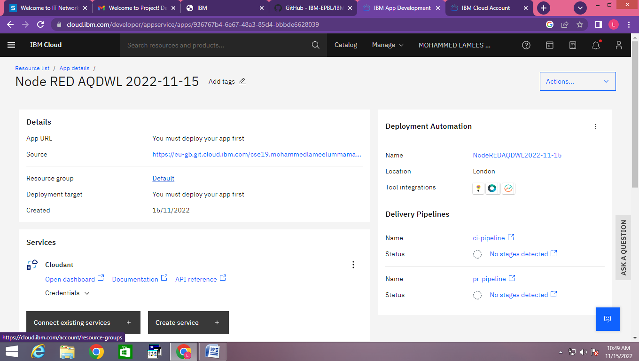

1. **Node-RED on IBM Cloud:**



1. **Start the NODE RED application to build the projects :**

